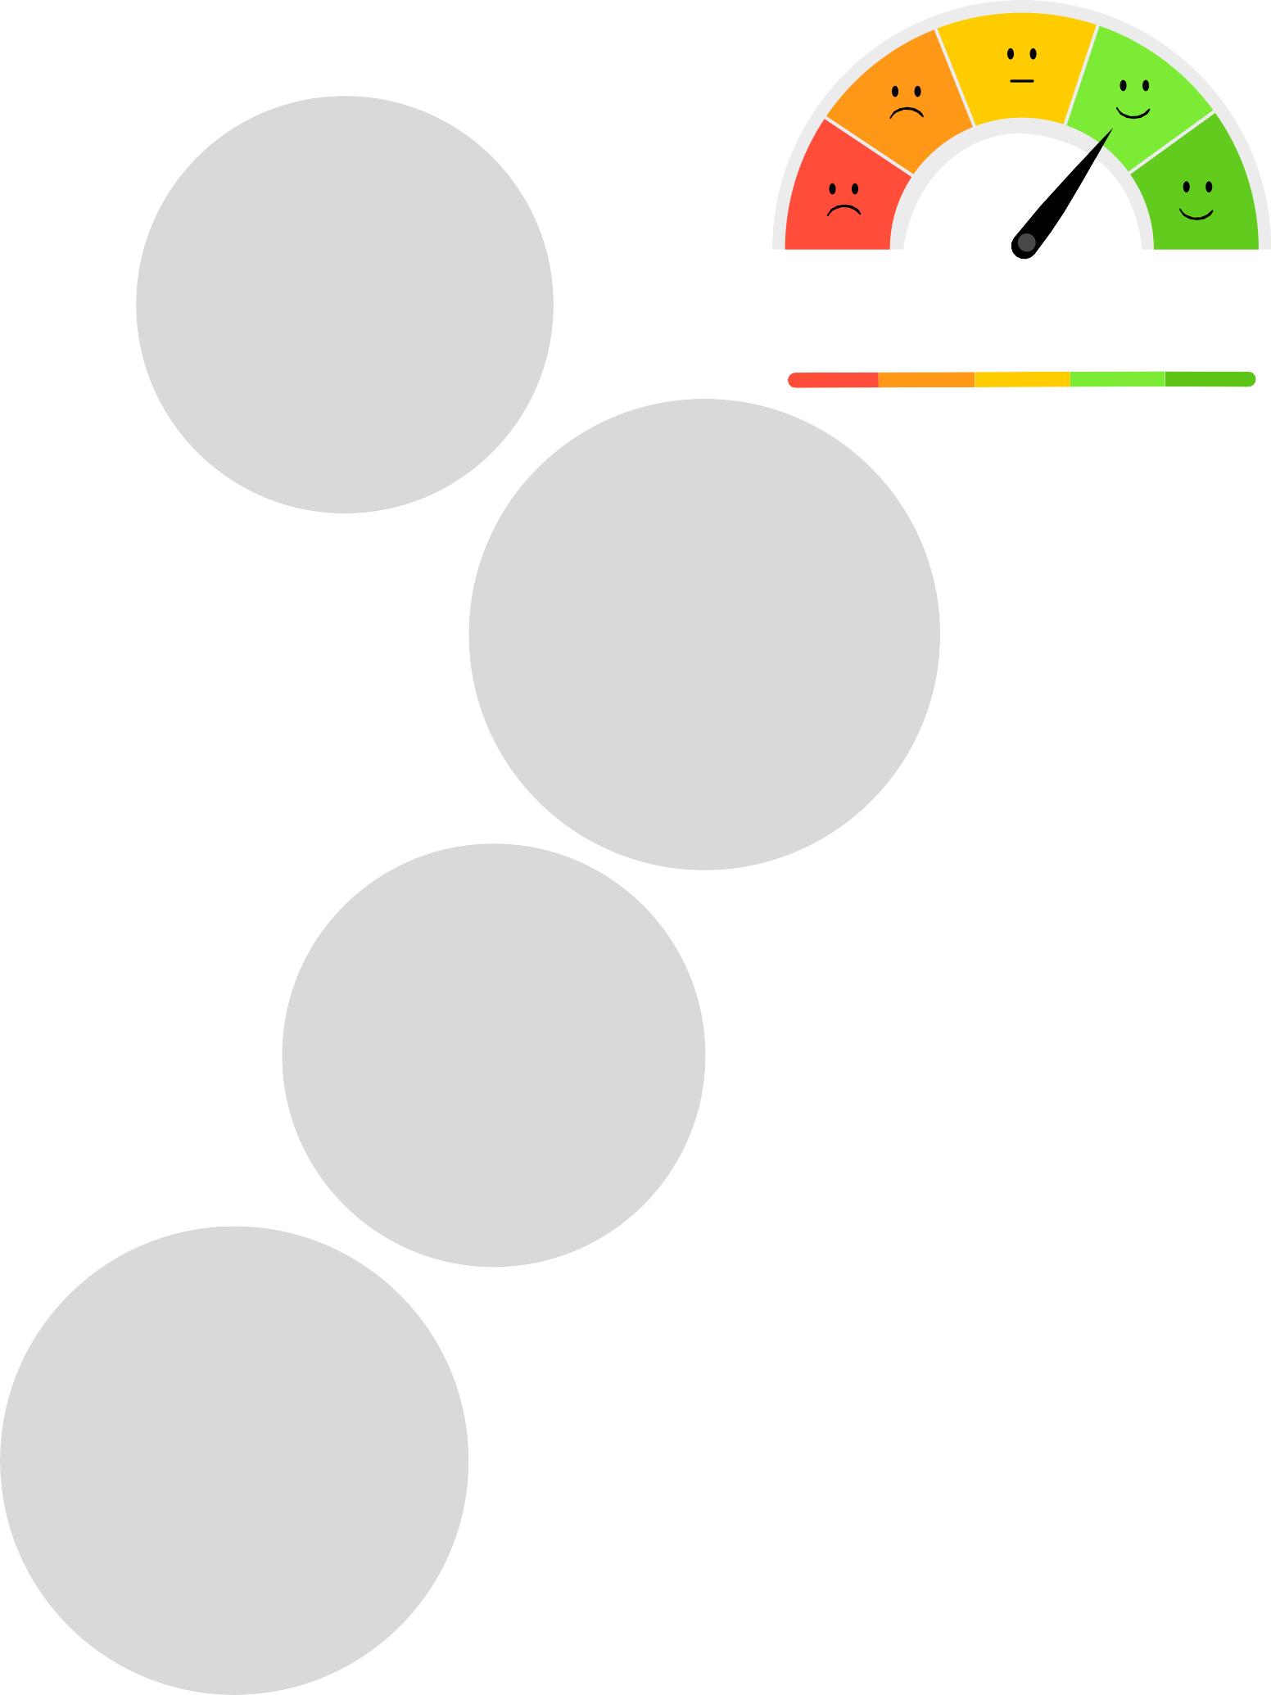
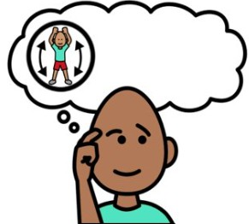


How I feel about “FOOD AND EATING”

Like  Okay
Don’t like

I don’t know


FOOD AND EATING

Hard OK

Easy

What foods feel good in my mouth?
What foods don’t feel good?
What foods feel safe and comforting?
Are there foods that feel too hard to eat right now?

How important is it to me?

Very important

Important

Not that important





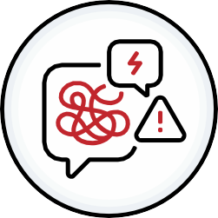



FOOD AND EATING
WHO HELPS ME WITH FOOD SHOPPING, COOKING OR PLANNING?
I WANT TO KNOW MORE ABOUT...
WHICH FOODS ARE IMPORTANT FOR MY HEALTH?
(diabetes, allergy, energy, mood)
THESE MAKES EATING HARDER?
I WANT TO EAT MORE OF…/

I WANT TO EAT LESS OF...

WHO COULD HELP ME LEARN NEW SKILLS?

WHAT FOODS OR ROUTINES ARE VERY IMPORTANT TO ME?

Planning for Food and Eating
What do I eat when I am stressed, tired or in pain?

What makes eating easier or harder?



In my body In my brain

My Food Routine
Who helps me with food shopping, cooking or planning?

Who could help me learn new skills?

Family, support workers, Allied health, medical services
What helps me remember to eat?

What do I eat most days?

